Fundamental Study:
Finding the velocity profile cross section and recording the average channel velocity.
Setup:
- Water level: 8.5 inches depth
- RPM: 300
- 5x5 data points collected.

Cross Section Measured
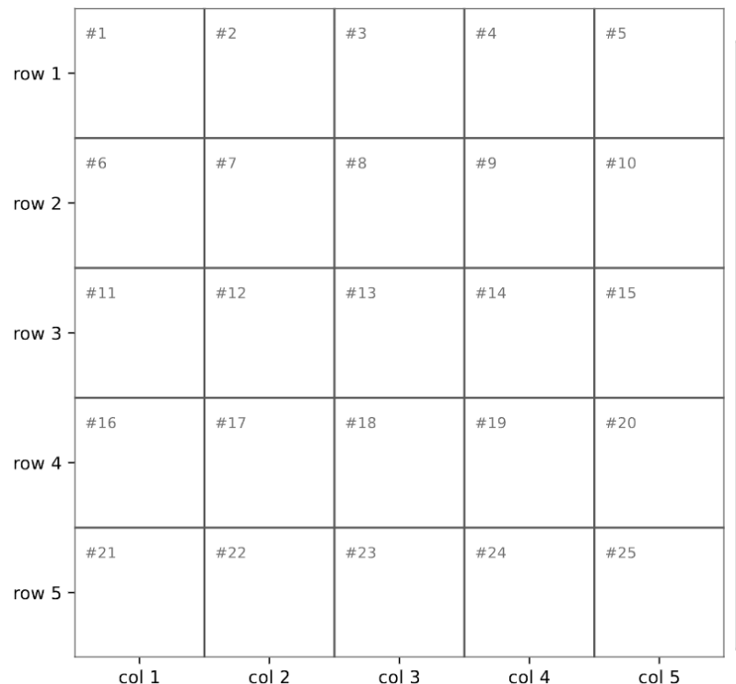
Inner wall
7.2 in

5.6 in
8 inches
total 4 in

2.4 in

0.8 in

1 in 3 in 5 in 7 in 9 in
10 inches total

Outer wall

Overview:
- Still water still recorded a velocity of 0.2 m/s and was not repeatable
- Running the motor initially increases velocity, but then levels out to still water velocity readings
- Velocity near the surface of the water is negative.
- Gradual decreases in velocity when changing pitot tube position
- Cross sectional profile does suggest fast water velocity towards the center of the tank

Observations:
Still Water
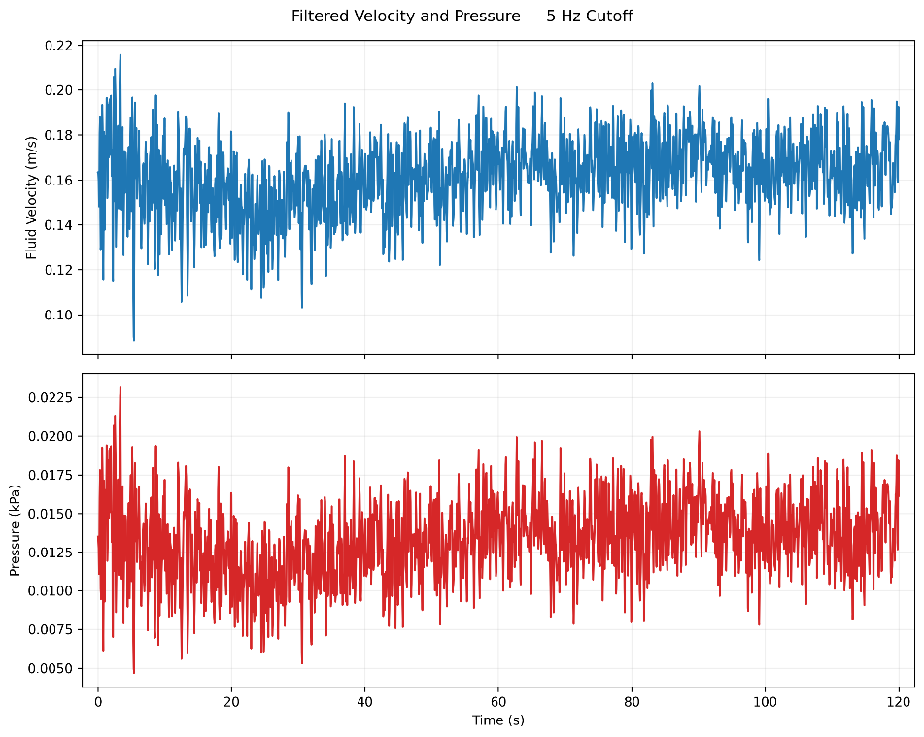
First testing was done with the pitot tube in water without the motor running. An interesting phenomenon occurred: velocity of the water was not zero and there were fluctuations in the velocity in seemingly still water. Multiple tests showed velocity ranged from 0.20 m/s to 0.1 m/s which intuitively seems incorrect.

Startup
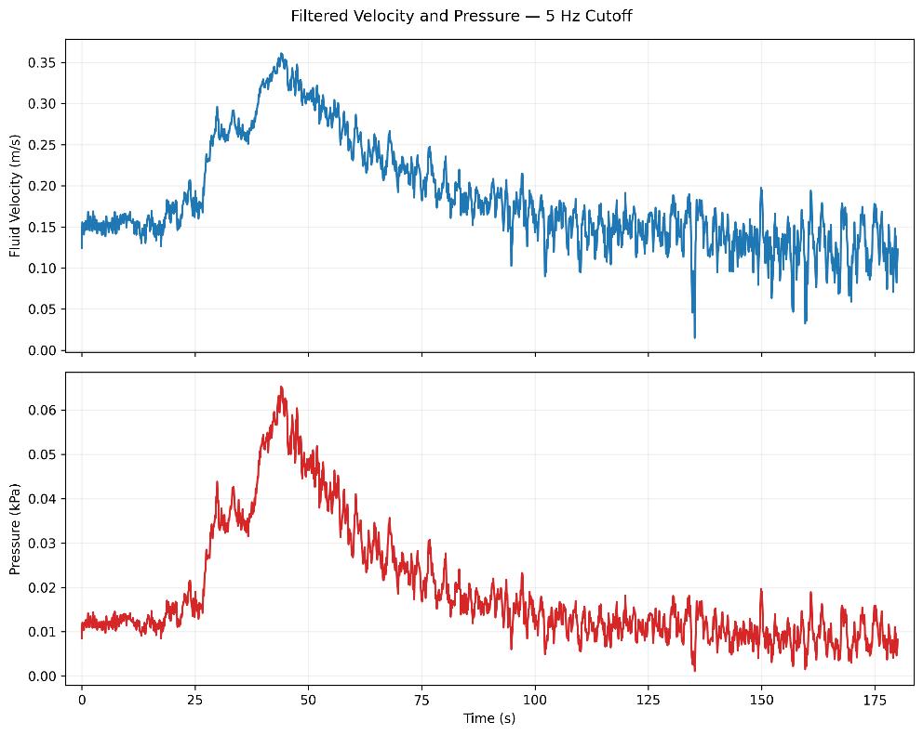
We observed that even after running the motor, the velocity would gradually decrease until becoming equivalent or even lower to still water velocity which is counterintuitive. To test this, we recorded velocity when starting up the motor over a long period of time to observe this effect.

Gradual Velocity Decreases
When moving the pitot tube, the decrease in velocity recorded was seen through various trials. We would record this trend and repeatedly take 30 second windows until we observed the dropoff rate was decreased. Here is an example for point 19 in the section with three windows of data at the same point.
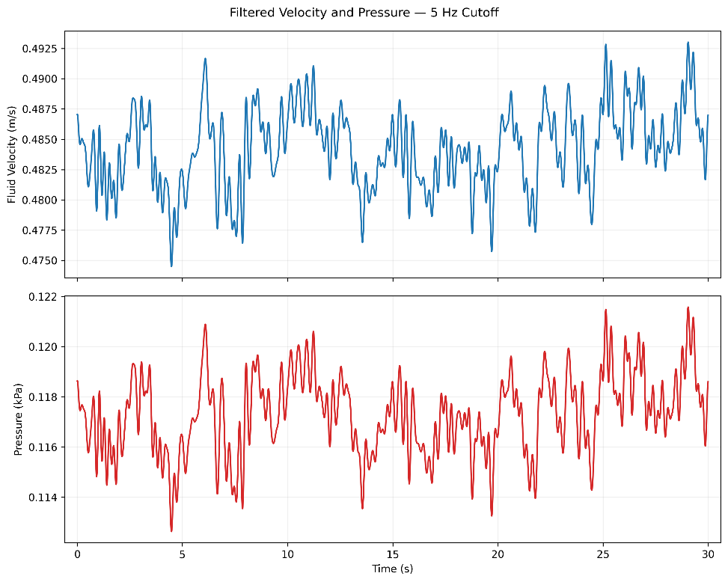
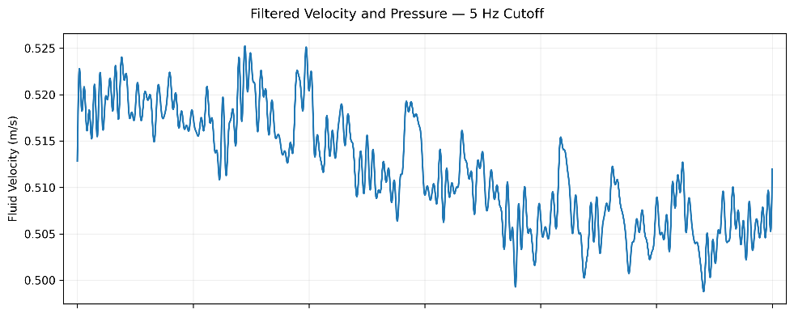
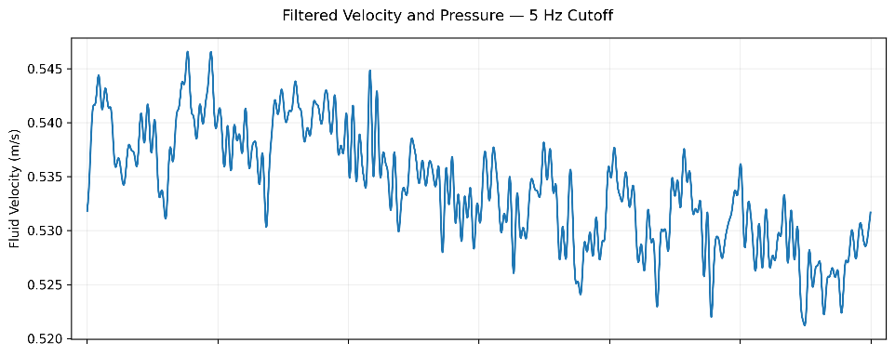

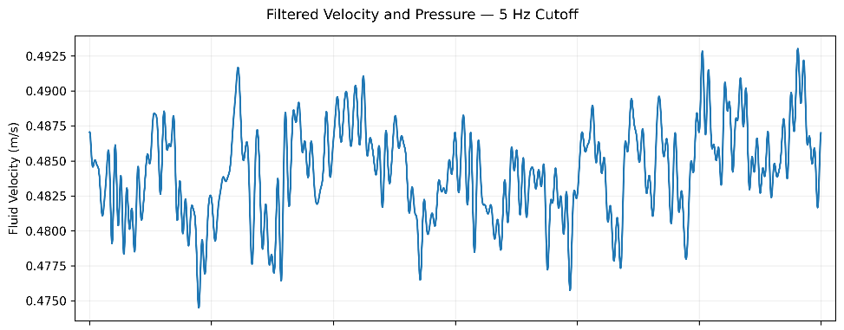

Cross Section Analysis
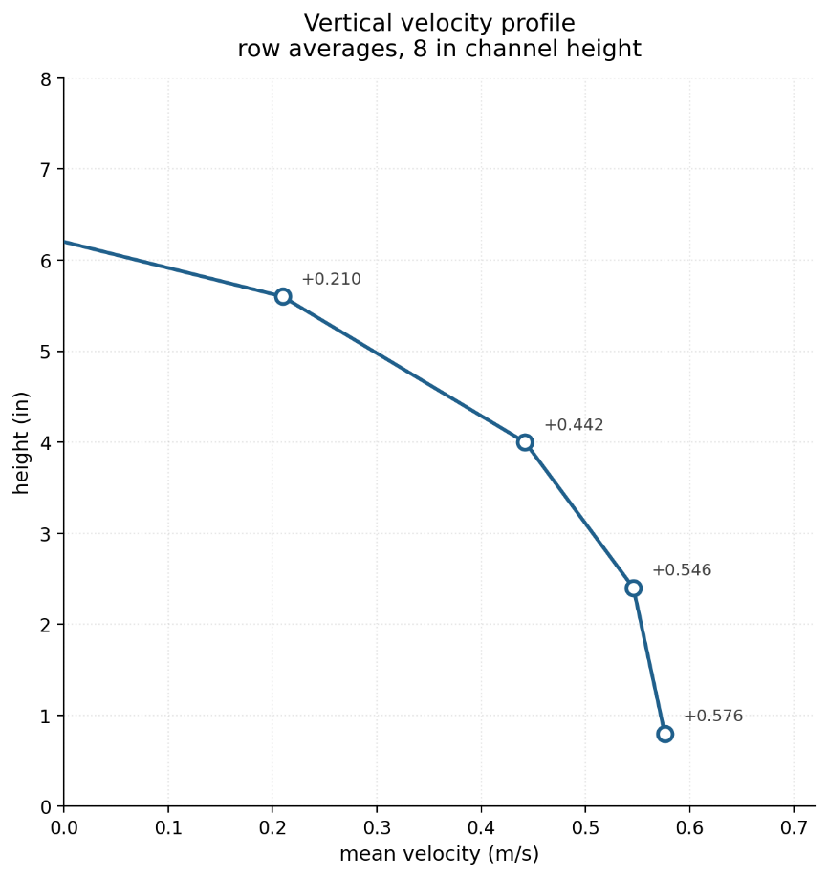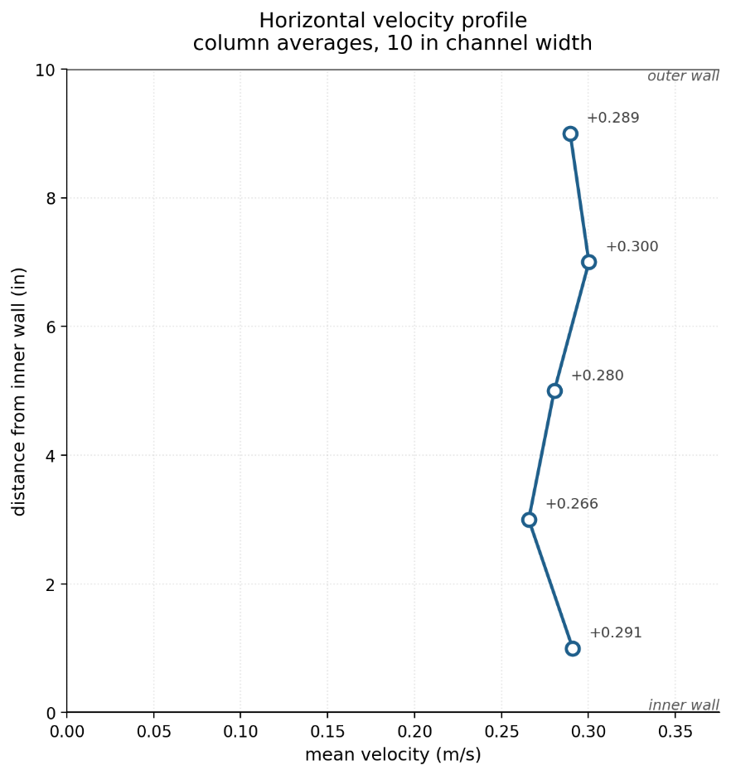
Overall Average: 0.285 m/s
AI Summary:
The profile doesn't look like a fully developed channel. Row means go −0.347, +0.210, +0.442, +0.546, +0.576 — monotonic top to bottom with a sign change, and column means are nearly flat (0.266–0.300). A developed channel cross-section would normally be roughly symmetric with a maximum near the center and low values at both walls. What you have looks more like a shear layer, a boundary-layer profile with recirculation near one wall, or a section where the flow isn't yet developed. Worth confirming which wall row 1 sits against.

